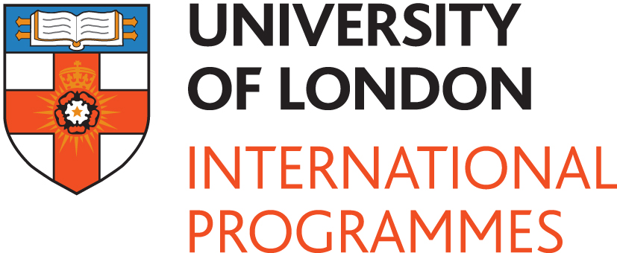

Contact:

Binda Rai: +44 (0) 20 7862 8545
+44 (0)7920 476483
Binda.Rai@london.ac.uk

21 February 2012

President of Seychelles holds talks with University of London Vice-Chancellor

A delegation of top Government officials, led by the President of the Seychelles, James Michel, visited the University of London this morning for talks with the Vice-Chancellor, Professor Geoffrey Crossick, and other university officials.

The President’s interest in the University of London stems back to 2009 with the establishment of the University of Seychelles. The University offers its students a University of London award through the University of London International Programmes. The International Programmes has offered flexible and distance learning to students worldwide since 1858.

Through this relationship with the University of London International Programmes, students of the University of Seychelles are now part of a global community of more than 50,000 students, on 100+ study programmes, in 190 countries.

President Michel, whilst expressing his pride at visiting the University of London, said: “I have always believed in education because education is the future, our youth are the future.”

Speaking of the relationship between the two Universities, President Michel said: “Since our inception, we have worked hard to provide an environment that will help young people acquire skills and knowledge, allowing them to move forward in a knowledge based society”.

He added: “The University of London is an institution which has been phenomenal over the years and we are delighted to be associated with it. I hope this relationship will continue to shine in the centre of the Indian Ocean – together we can provide Seychellois people with access to an education of the highest quality”.

Professor Geoffrey Crossick, Vice-Chancellor of the University of London, said: “Our relationship with the University of Seychelles follows a long tradition of our supporting the establishment of Universities across the Commonwealth, such as University College of Ibadan in Nigeria and the University of Nairobi. Not only has the University of London been a key player within the Commonwealth, but also at home in the United Kingdom with Universities such as Exeter and Nottingham, both of whom began by teaching our awards”.

Professor Crossick added: “We are very pleased to be supporting the University of Seychelles, which aspires to become an educational hub in the region.”

-ENDS-

Notes for Editors

Photographs available on request.

University of London International Programmes

- The University of London was established in 1836 and is one of the oldest, largest and most diverse universities in the UK. Its founding principle is to provide education for all, irrespective of race, creed or political belief.
- In 1858, the University of London was granted its fourth Charter, which paved the way for the establishment of the University of London External System, known as the University of London International Programmes with effect from 1 August 2010. This makes the University of London International Programmes the world’s oldest provider of degrees through distance and flexible learning.
- The University of London International Programmes is a unique global network of more than 50,000 students in over 190 countries, on 100+ study programmes.
- Famous former students and alumni include seven Nobel Prize Winners: Sir Frederick Gowland Hopkins, Professor Ronald Coase, Wole Soyinka, Derek Walcott, former President Nelson Mandela, Charles Kao and Dr Rolph Payet.
- Explore the range of study programmes available to students of the International Programmes: http://www.londoninternational.ac.uk/prospectivestudents/.

University of Seychelles
- In 2007 the President of the Republic of Seychelles, James Michel, announced that the Seychelles was ready to develop a University. The Seychelles University Foundation (SUF) was established the same year and given the task of taking the project forward. The University of Seychelles opened in 2009 and teaches study programmes delivered through the University of London International Programmes.

